Product Functionalities:

1. Selectable function: the selectable function such as selecting a new project or a plan is very unfriendly to the users. It can design some icons to let user click visually and directly, no needing the time to skim the menu and pulling it down on the user interface   
  
2. Observing camera: This function allows the users to see the whole view of 3D graphic, following the mouse to see the model from different angles .Moreover, it can also put some marks on the 2D graph to generate a route for camera and then export a video.but, I consider it could be improved by using pause and zoom for generated video to see a specific item or space.  
  
3. furniture catalogue: it has various different kind of items to insert into the room, but some a of them are redundant ,including battery, stapler, text marker ,pen ,phone, sitting female, standing females, horse... .Such objects are trivial which is unnecessary to put into the catalogue. Instead, it could add some children's playing spaces or swimming pool to make it more useful.   
  
4. piece of furniture: the function is designed to choose furniture. However, while switching to searchable list mode and choose the all catalogue, the furniture display should be split into pages instead of loading all of them, otherwise it may consume memory and user normally does not want to see them all in one page.

5. home furniture list displays the current selected furniture in the plan, it should have a type column display while sorting by type. And also, it should be able to search specific furniture by entering keywords as it did in the furniture catalogue.

6. the 3D view of home could display in another window, which save more space than having 4 sections in the same window. And also it could be enabled by a function because users are less likely to see the 3d view in real time.

7. It should provide some well-known compamy's furnitures ,such as sherwin williams,kohler zodiaq, flex deck,merillat.Since those furniture are in mass production, the size are standard.Thus, it will not need too many parameters to set every product's length ,width ,height and then it will make it easier for users to get a standard size.

With a buttom,softeware can help users to list the items they need and order online, even sending to their home.

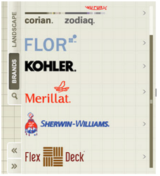

source :autodesk homestyler

8. It can not build a roof since Sweet Home 3D supports the creation of ceilings seen from below, but doesn't manage the creation of roofs yet. Therefore, it use various tricks to cover a house: if the roof is flat, we can draw rooms in a level matching that roof, which may not be a good way. However, "Google sketch up "can easily build a roof with any style, such as [red slate roof](http://www.sweethome3d.com/models/contributions/toitureArdoiseRouge.zip) or [polygonal roof](http://www.sweethome3d.com/models/contributions/polygonalRoof.zip).

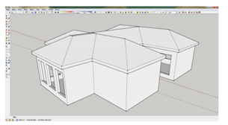

souce:google sketch up

9. When we need to download and import more models to the Sweet Home 3D , some of these models provided by supported websites can not be imported. Thus, I consider it can create and manage a model database, with a link to the valid models from other websites, in case of wasting time on browsing models online .

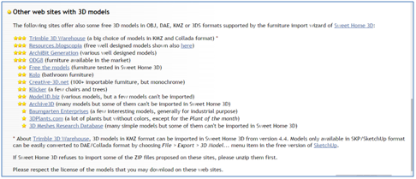

10. The 2D graph can zoom in and out to the whole view,whereas the 3D graph can not.

11. In order to change the rotation of a specific furniture, it can only use mouth or setting a value to rotate. By improving this, it can add a function by rotating an item 90 degree per left click.

12.The function of "displaying the 3D graph in an independently window" is bad, because it cannot maximize the screen by a click. User have to drag the window edge to have a proper size of view.

13.When building a second floor, we have to set the visual height of a camera to see the model at that level. I suggest as user editing a particular floor , the camera can directly display the view at that floor without changing the height of view. It just need adjusting position and angles of the camera to see the whole view.

* Main architectural blocks

The following figure illustrate the main architectural blocks of the project (code blocks, modules, data structures, functions, etc.). This figure is a package level diagram. It illustrates the relations of the different packages present in the system along with all the possible interactions between these packages.

# 

The primary architectural blocks of the project is a HomeApplication, which aggregates one or more possible homes. The home contains various types of data models, such as pieces of furniture. One of the main blocks a HomeApplication has is the ViewController for displaying 2D and 3D views created by the specigic view factory. There is also a plugin module which uses a plugin controller to maniuplate the external plugin.

# Important Data Structures:

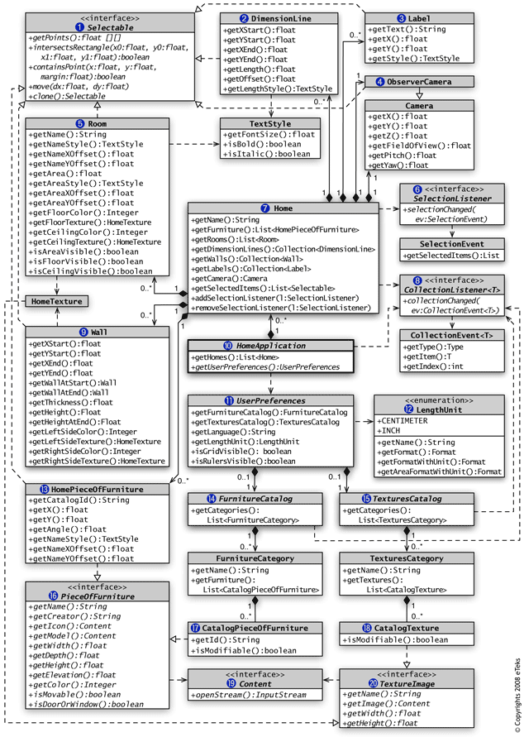

The website has provided a detailed diagram which has all the data structures present in the tool. As can be seen in this diagram, the three most important data structures in the Sweet Home 3D interior design tool are:

* Selectable
* PieceOfFurniture
* View

The way these three data structures interact can be easily understood. A PieceOfFurniture object is a specific type of Selectable object. PieceOfFurniture objects along with other Selectable objects both appear in View objects.

* Analysis

There is not any different versions to compare the the architectural blocks and data structures. The first high level operations over those data structures is display the furniture

catalog, and second one is drap and drop one selected furniture into a window pane.

We can't discover all defects in the early stages, but there are things we can do to move discovery of defects earlier.

1.First, consider the life-cycle of the product, the consequences of failure, the cost of a field repair.

2.Choose appropriate algorithms and consider the target environment, now and future during design and analysis.

3.Choose languages which permit easier discovery of defects. [StaticTyping](http://c2.com/cgi/wiki?StaticTyping), for instance, can detect most type errors at compile-time .

4.Choose languages with programming models that reduce the possibility of error.

5.[UnitTest](http://c2.com/cgi/wiki?UnitTest). It is preferable to find and repair defects at the developer's desk before the code is committed and then to find them during acceptance testing.

Perform acceptance testing, including in an environment which simulates that of the customer, and by testers who can simulate the behavior of the end user. Should be obvious, but still too many managers (and engineers) consider testing to be overhead.

6.Use a [TrackingTool](http://c2.com/cgi/wiki?TrackingTool). Generally, it's an Excel spreadsheet or a whiteboard in the lab, which can track the status and the date of the bug.

# Product Functionalities:

This section details three product functionalities described from the point of view of the user.

1. 3D Space Viewing Camera (Virtual Visitor)

The Viewing Camera in the 3D rendering part of the SweetHome3D tool is a fundamental part of the product’s functionality. This is the part of the toll which actually allows the user to view the 3D rendering based off a given 2D plan. It allows the user to navigate around the rendering of the home using a number of controls. For example, the mouse wheel can be scrolled in or out to zoom in or zoom out of the view, giving a slimmer or broader view of the building. The arrow keys can be used to rotate user’s view around a given point. This can also be achieved by left-clicking, holding and then dragging left or right. The up and down arrows can be used to move the point of view forward or backwards. Aspects of the viewing camera can be changed using the drop down menu labelled “3D View”. For example, selecting “modify virtual visitor” opens a pop up box where the camera’s position can be changed.

2. 3D Photo Capture

The SweetHome3D interior design tool gives the user the option to take photos of the rendered 3D graphic of the building they are working on. To capture these photos the “Create a photo from 3D view” button must be selected. This is a black camera icon which is third from the right on the icon quickbar at the top of the program. Once this is selected the user has a number of options available to them. The size of the image, in terms of pixels (width and height) must be chosen, or desired proportions must be set. The quality of the photo is then also selected. The quality is represented as a range with four options from Fast-Best at each end. Fast takes a quick photo exactly as everything appears in the 3D rendering. On the other hand, best has global illumination with shadows in the photo which are computed from the lights placed in the plan. Once the user is happy with all these options, the photo must be created. A rendering of the photo will appear which may be saved to a desired location on their computer if the user still wants the photo.

3. 3D Video Creation

The SweetHome3D system also allows the user to create 3D videos which can be saved and viewed at a later date. To create such a view, firstly the “Create a 3D Video” button is selected. This button is second from the right on the icon quickbar. It looks like a small grey camera. The user chooses a set route for the camera to follow. The camera may also rotate or move vertically during the video, allow the user many types of animations. Once the user is satisfied with the video, they may save it to a desired location on their computer.